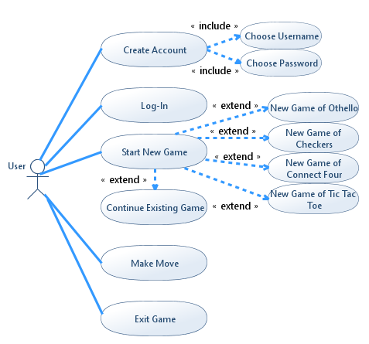

|  |  |
| --- | --- |
| Use Case Name | Create Account |
| Actors | User |
| Scenario | New user accesses game suite and must create an account |
| Trigger Event | User opens the game suite file and is prompted to log on |
| Brief Description | All users must have an account and if a new user opens the game suite they must create an account in order to use the suite |
| Precondition | User opens game suite |
| Post Condition | User is logged on and is at main menu |
| Flow of Activities | 1. User opens game suite on computer 2. User is prompted to log on 3. User chooses create new account 4. User makes username and password |

|  |  |
| --- | --- |
| Use Case Name | Log-in |
| Actors | User |
| Scenario | User is prompted to log-in |
| Trigger Event | User opened the game suite |
| Brief Description | User has to log-in with their account username and password in order to access the game suite |
| Precondition | User clicked on the game suite |
| Post Condition | User will have successfully logged on to the game suite |
| Flow of Activities | 1. User opens the game suite from their computer 2. User enters their log-in information 3. Users successfully log on and are at the main menu |

|  |  |
| --- | --- |
| Use Case Name | Start New Game |
| Actors | User |
| Scenario | User is at the main menu and wants to start a new game, or continue an existing game |
| Trigger Event | User logged on |
| Brief Description | User can start a new game or continue an existing game |
| Precondition | User is at the main menu with an option to start a new game |
| Post Condition | User will have started a new game of the game of their choice or continued an existing game |
| Flow of Activities | 1. User logs on to the game suite 2. User chooses ‘Start New Game’ from menu 3. User can choose to start a new game of Othello, Connect Four, Tic Tac Toe, or Checkers 4. Or the user can choose to continue an existing game |

|  |  |
| --- | --- |
| Use Case Name | Make Move |
| Actors | User |
| Scenario | The user has either started a new game or is continue an existing game |
| Trigger Event | User chose ‘Start New Game’ or ‘Continue Existing Game’ |
| Brief Description | User will see the updated board of whichever game they’re currently playing and will be able to make a valid move for their turn |
| Precondition | User is viewing the game board |
| Post Condition | User will have made a valid move and will have either won/lost or it will be the other player’s turn once again |
| Flow of Activities | 1. User chooses ‘Start New Game’ or ‘Continue Existing Game’ 2. User see’s the game board 3. User uses mouse to make their move |

|  |  |
| --- | --- |
| Use Case Name | Exit Game |
| Actors | User |
| Scenario | New user wishes to exit the game for some reason |
| Trigger Event | User is viewing the game and has the option to exit the game |
| Brief Description | User can choose to exit the game if they don’t wish to make a move at the time, change their mind and don’t want to create a new game, or any other reason they may have |
| Precondition | User clicked the ‘Exit Game’ button |
| Post Condition | User will have exited the game and will be back at the main menu |
| Flow of Activities | 1. User is in a game 2. User clicks ‘Exit Game’ |